06/11/2018

Tetaud Sebastien

TE-VSC-BVO

PytPlot Installation

# Install Python

Go to G:\Departments\TE\Groups\VSC\LBV\VAC113\Software\PyPlot\Installation and install

python-3.7.1.exe.

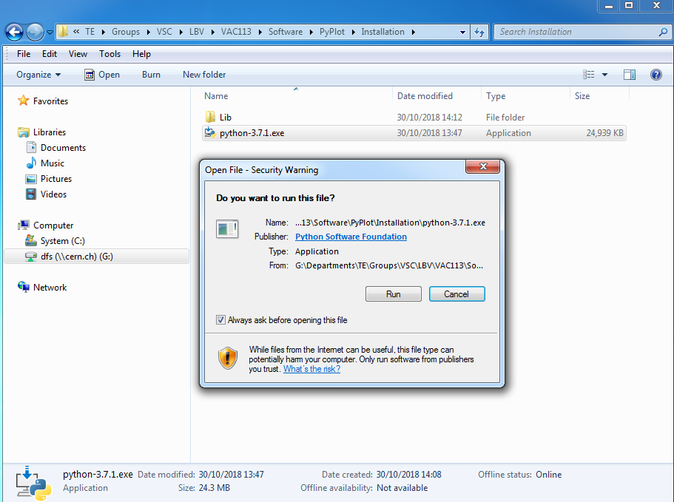

Step 1

Step 2

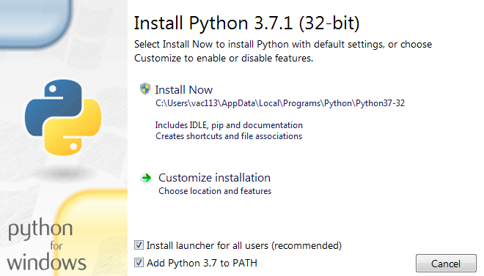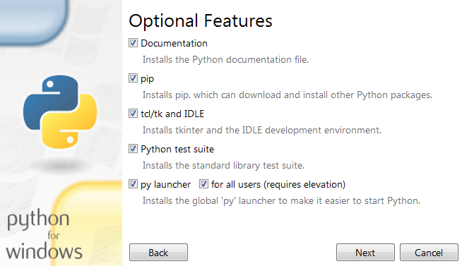

Step 3

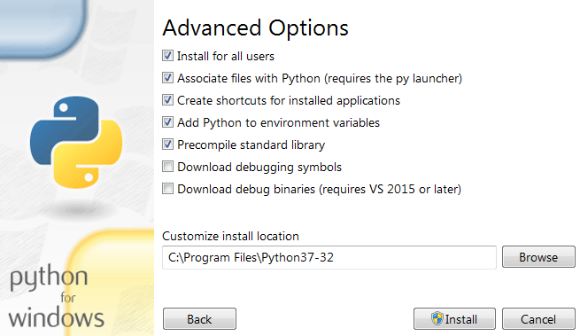

Step 4

# Install Python Packages

Run the PyPlot Packages as administrator (shift + right click) and wait for the installation. When the installation is finished, the window will close.

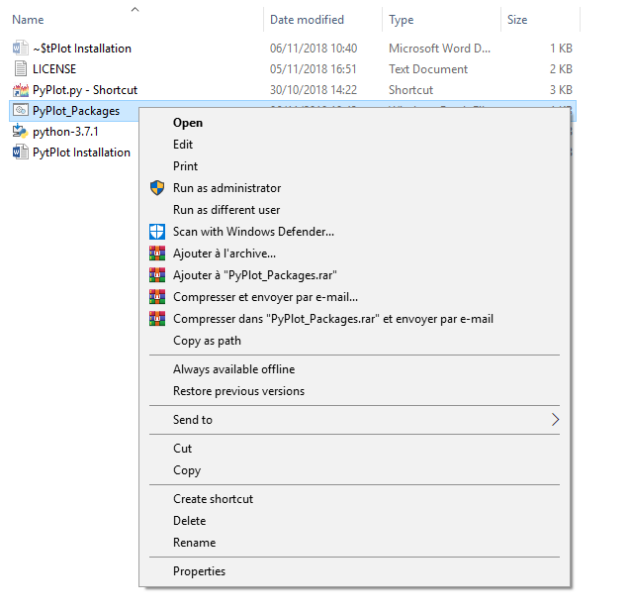

* PyPlot is ready to use.